Dan Tamulonis
27 February 2014
Chromatography Lab Report
Section 005
Partners: Ajia Lui and Ryan Swinson
Stephanie Le Claire

Introduction:
Today’s world is full of an infinite number of colors: shades, tints, and hues built from combinations of primary colors. We enjoy them and often take them for granted. Few people other than artists and product designers understand the complexity of colors and that a specific red color, for example, could be a precise blend of one type of red dye, one of yellow, and one of blue. Color is so ubiquitous in the industrial world, and the commonly used dyes that create color additives for products are so important, that the U.S. Food and Drug Administration (FDA) defines and regulates them. FDA regulations apply to a group of specific dyes known as the Food, Drug, and Cosmetic (FD&C) dyes. They are split up into those that could be put in food and those that are purely used for industrial means (i.e., pen ink) (1).
Since most colorful compounds today are not one color, but a composition, it is hard to tell what they truly comprise. In order to figure out the composition of a color there must be a way to separate mixtures. A technique to accomplish this is known as chromatography. This word literally means to write with colors. It was preliminarily used by Mikhail Tswett to analyze different color pigments found in plants. The process of chromatography separates out the different dyes, allowing them to be analyzed individually. There are multiple types of chromatography. Each technique has its own pros and cons but all are very helpful in getting a general idea in respect to identifying each ink (3).
The type of chromatography that is analyzed in this lab report is paper chromatography. In this process, the experimenter creates a chromatogram, beginning by choosing a piece of paper and marking a line 0.5 cm from the bottom of the sheet. The mark is made in pencil because graphite is not composed of dyes, and so it will not interfere with the experiment. The next step is to mark out each mixture on the aforementioned line, spacing them equally. Note that it is important to create a reference that documents which mixture is where on the chromatogram because once the dyes separate it becomes hard to distinguish which was which originally. In chromatography, there are two defined phases: the mobile phase and the stationary phase. These phases are what describe the components either travelling, or not (4).
The mobile phase solvent is the liquid solvent that you place the chromatogram in. A component dye will travel up the chromatography paper as long as it has affinity to the mobile phase solvent. This solvent drives the components up towards the top of the paper. This is known as the components being in the mobile phase. Once the dye stops travelling with the mobile phase solvent, it enters the stationary phase.
The affinity between the component dyes and the mobile phase solvent is based on polarity. Polarity is caused by unbalanced charges in a molecule. Water is an extremely polar molecule. If the solvent is very high in polarity, it is likely that the component dyes will not travel very far because they are not that attracted to it. If the solvent is not very polar, then the component dyes will travel to the top of the paper (6). The upper limit of where the mobile phase solvent travels is called the solvent line. Because of the relationship between components and the mobile phase solvent, it is important to find the right solvent for a group of samples. Some solvents will render useless information, while a more polar solvent might leave a chromatogram that can help identify each component for every sample.
Some of the more important pieces of information that can be taken from a chromatogram are retention factor (R_{f) values}. These values can be calculated by measuring the distance the component has traveled divided by the distance the solvent traveled (the solvent line). This value yields a relative rate of flow in respect to the solvent. This value is pertinent only if all contributing variables remain constant, such as the composition of the solvent.
Chromatography is important because it allows chemists to identify unknown inks and mixtures. A chemist may know what a mixture is called, but not its component parts. Paper chromatograms allow for the identification of these unknowns in terms of composition. Note that some chromatograms need to be further analyzed under UV lights because the yellows are hard to see regardless of the quality of the chromatogram.
Since we are trying to find the different components of 15 different pens (three colors; five brands), then I think we should change the mobile phase solvent to something more polar because when we performed the chromatogram earlier with 2:1-propanol:water mixture, the pen inks all traveled to the top of the chromatogram and did not separate at all. If I am trying to get separation, then I would use a solvent more polar than 2:1-propanol:water because that would cause the components to travel a shorter distance, causing the inks to partition between the mobile and stationary phases.

Procedure:
The procedure I followed was taken directly from the PSU ChemTrek experiment book for Penn State CHEM 111/113 (3). To carry out this lab, I needed lab partners. My partners were Ajia Lui and Ryan Swinson (7)(8).
The first part of the lab was identifying the polarity of the 2:1-propanol:water mixture. This was done using the Snyder Polarity Index (9), which is a reference table stating known polarity values of certain substances, such as propanol and water. It was important to know how polar the propanol mixture was because my hypothesis stated that I needed to use a more polar mobile phase solvent. This statement is useless unless I know the polarity of the 2:1-propanol:water mixture.
The second part of the lab was setting up the first paper chromatogram. We each made our own so that we could evaluate multiple mobile solvents. The first step was drawing the line 0.5 cm around the entire base of the paper. Next, 15 intervals were measured out, one for each pen. So that they fit on the paper, each was marked at 1.0 cm apart from each other. These were then marked by the fifteen pens in a specific order (Figure 1).
Figure 1. Chromatography of Pens
Spot # on paper | Pen Color | Pen Brand
1 | BLACK | Papermate
2 |  | Pilot Easy Touch
3 |  | Bic
4 |  | Staples
5 |  | Pilot V Ball
6 | RED | Papermate
7 |  | Pilot Easy Touch
8 |  | Bic
9 |  | Staples
10 |  | Pilot V Ball
11 | BLUE | Papermate
12 |  | Pilot Easy Touch
13 |  | Bic
14 |  | Staples
15 |  | Pilot V Ball

The next step was to create a mixture of a polarity higher than 2:1-propanol:water but less than that of pure distilled water. Ajia, Ryan, and I each made our own mixtures within those constraints and poured a thin layer in a petri dish. We placed our chromatograms in the petri dish, after stapling the ends together to form a cylindrical chromatogram that could stand on its own. A clear plastic cup was then placed on top of each of them so that moisture would not escape the experiment. I observed the progression of the mobile phase solvent up until the point where it was approximately 0.5 cm from the top of the paper. When it reached this point I stopped the experiment and marked the solvent line with a pencil. I then set the paper to dry by taping it to a ring stand. It is important to mark the solvent line before it dries out because it will be impossible to see later.
This portion of the experiment was repeated up to three times by each of us until we obtained a usable chromatogram. We referenced the polarities of our respective solvents in order to narrow down a possible polarity range. Each time it got narrower because we could see that a certain polarity level would not yield a quality chromatogram. The quality chromatogram became the standard.
This was the clear first part of the experiment. The second part of the experiment was using this new standard chromatogram to test new chromatograms. We were given five unknowns and the task was to identify which pen was represented by which unknown. To compare the unknowns, I ran another chromatogram with the unknowns and compared it to the standard. With this chromatogram, it was important to make sure we used the same mobile phase solvent that was used for the standard. This allowed me to compare it to the standard and figure out which pen it is.

Results:
After calculating the polarity of 2:1-propanol:water, I found it to be 5.9, according to the Snyder Polarity Index. I performed this calculation by using the given values of propanol and water, while accounting for each part propanol in respect to parts water.
Propanol = 4.3 polarity
Water = 9.0 polarity
2:1-propanol:water = [(4.3 x 2) + 9.0] /3 = 5.9 polarity
This shows that the polarity needs to be between 5.9 and 9.0 because the chromatogram needs to enter the stationary phase earlier than it did with the 2:1-propanol:water mixture, but not as late as water. So the established range is between those two polarities.
Range: 5.9 – 9.0 polarity
My first trial was a 1:1-ethanol:water mixture. This mixture boasts a polarity value of 7.1 (calculated the same way as 2:1-propanol:water), which is in the correct range. The inks were put on the paper in the order provided in Figure 1. Carrying out the chromatography experiment showed that this solution was not polar enough because the inks all traveled to the solvent line, and with very little separation between components.

Trial 1
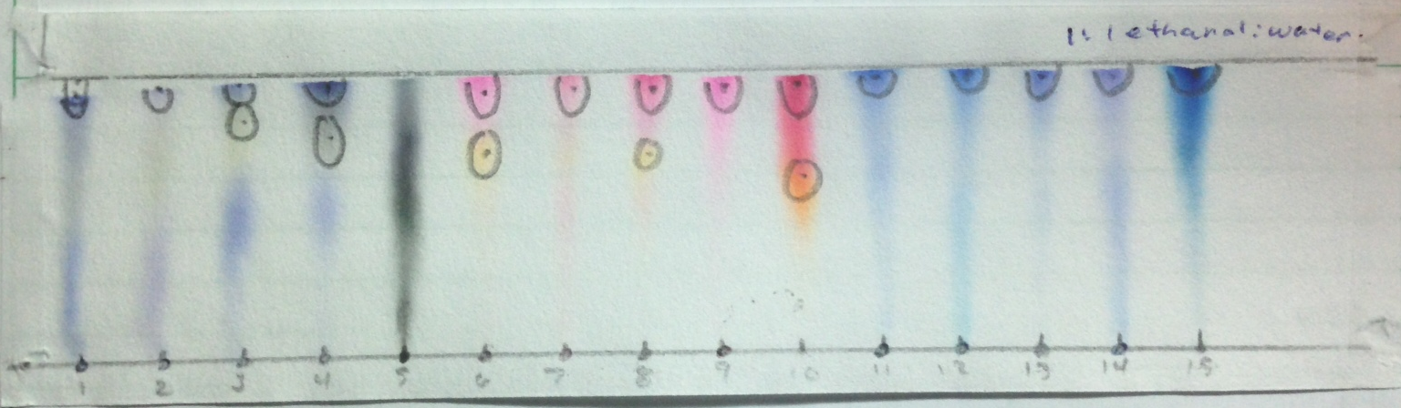
Trial 1 had too little separation to be tagged as the trial to use as a standard. Ajia’s 1:2- methanol:water trial (8.2 polarity) was the opposite of mine. It was too polar so most of the inks stayed in the stationary phase and failed to travel up to the solvent line. Ryan’s pure methanol sample (6.6 polarity) had strangely good separation and did not have every component travelling up to the solvent line. This could have been an outlier because it had a lower polarity value than my sample, yet yielded a result that would lead one to believe that it was actually higher.
None of the trials were good enough to be a standard but they helped create a new possible range of polarity values that was much more specific. This new range was:
New range: 7.1 – 8.2 polarity
This is much more specific than before. For trial 2, every solvent was within this new constraint. My second trial used a 1:2-propanol:water mixture (7.4 polarity).

Trial 2
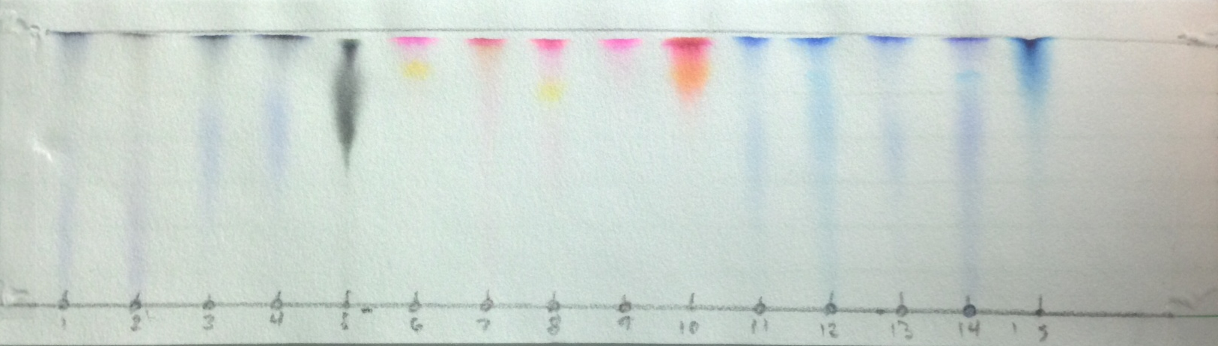
Trial 2 came out extremely poorly with almost no separation at all. Each line is much more faded than in Trial 1. The only color that separated any better was the yellow in pen 6 and pen 8. Those were not as clear in Trial 1 as they were in Trial 2. Overall, Trial 2 was not the standard we were looking for.
Ajia’s trial was 1:1-methanol:water (7.8 polarity) and this displayed almost all of the same results as her first trial. When comparing them side-by-side they were extremely similar. The blacks and red pens all traveled a little bit further up, which is to be expected, but it was not enough to make this chromatogram our standard. Ryan’s second trial was a 3:2-methanol:water mixture (7.6 polarity) and it turned out to work well for separating the red pens apart; however, neither the blue nor the black pens reached the solvent line. They came up extremely short, in fact making it hard to keep as a standard. This meant that we all had to perform a third trial. At this point the range was not more specific. We knew to make it a polarity of less than 7.8 but more than 7.1.
My third trial was 2:3-ethanol:water (7.5 polarity) and it turned out to be even worse than the second trial. It was just as faded, but none of the inks made it to the solvent line except the last blue pen. There was a little separation between the red and yellows for the red pens, but not much more was going on in this trial.

Trial 3
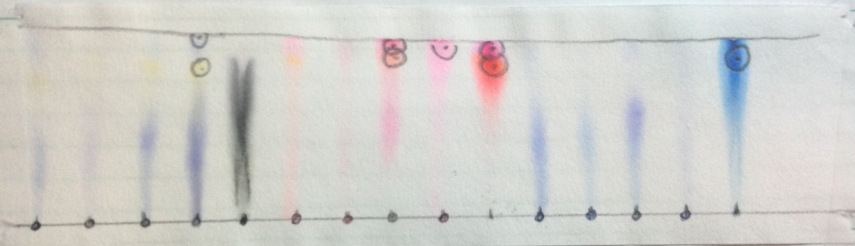
Ryan’s third trial, a 2:2:1-methanol:water:ethanol mixture (7.3), did not turn out as well as his previous two. For the red pens, the yellow dye did not separate as much as it did for other trials.. Ajia’s third trial, 2:1-methanol:water (7.4), was really good, however.
Ajia’s Trial 3
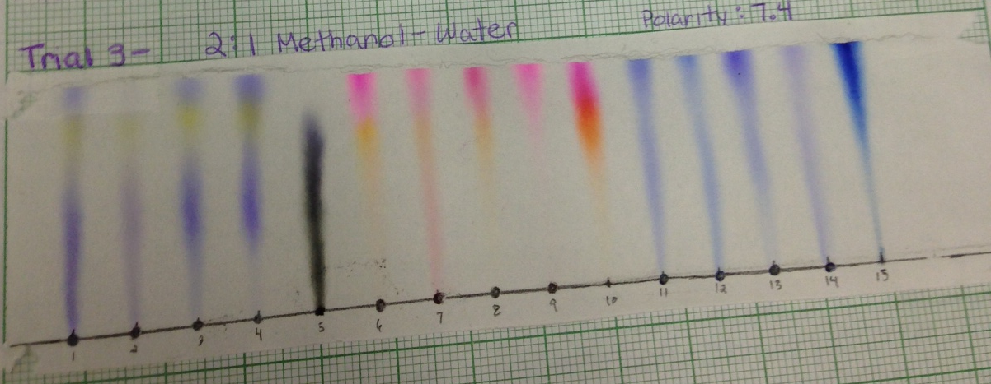
This trial had clear separation of the dyes within each ink, and small color differences could be seen within in the colors as well. This was the only sample that had really good separation of the yellows from the blues for the black pens. Because of these reasons, it made sense to make this the standard.
The purpose of performing these trials was to get a standard to test unknowns. I ran a chromatography with the unknowns on the paper in the 2:1-methanol:water mixture. When it was complete this was what the chromatogram looked like.

Unknowns:
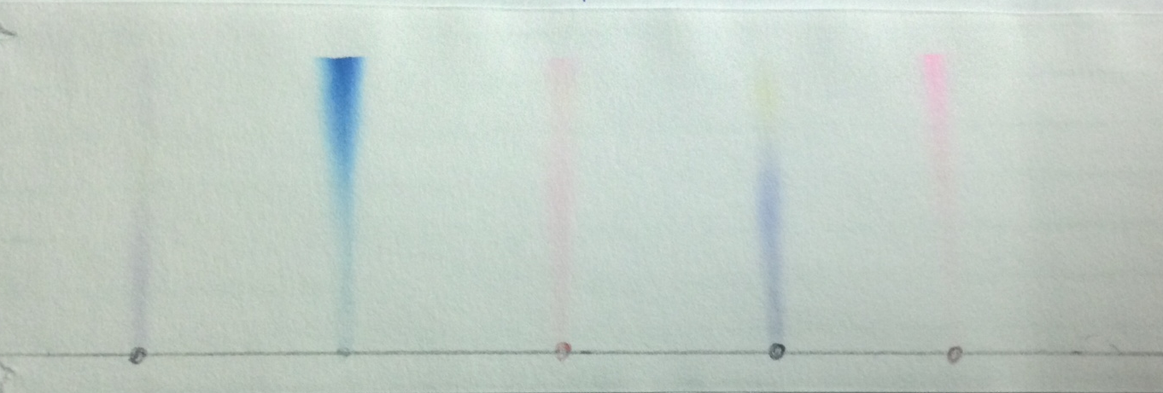
1 2 3 4 5
The unknowns came out well enough where the standard would be adequate for comparison. Unknown #2 was the easiest to define because the Pilot V Ball Blue pen was always different from the other blue pens. It had a different, strong bold color, which was what unknown #2 was as well. I then analyzed the two black pens (unknowns #4 and #5). Unknown #1’s composition was a much lighter bluish dye than the bluish dye that was in unknown #4s. This lighter blue cannot be seen in the other black dyes when referencing the standard. Clearly the second black pen (Pilot Easy Touch) matches up with it. Unknown #4 was hard to determine based on color alone because blacks #’s 1, 3, and 4 are all the same exact colors. Instead, I had to look at the specific shapes of the ink columns. Unknown #4 has a very full column shape. The only black pen that shared this was the Papermate black pen. This leaves the two reds. These were the hardest to determine by far. The main attribute distinguished unknown #3 was that it went from the bottom line all the way up to the solvent line. Pen #7 (Red Pilot Easy Touch) was the only one that displayed this characteristic so I determined that unknown #3 was indeed this pen. It took awhile for me to discover any distinguishing characteristics for unknown #5. At first I thought it could have been any of the red pens, but then I noticed the lack of yellow dye. The only red pen that had no yellow dye was the Red Staples Pen, so this had to be that.
Through this reasoning, I got all of the unknowns correct on the first attempt.

Dicussion:
Our lab group did not look at is each chromatogram as getting the solution, but rather as a way of getting closer. Each time we did a set of chromatograms, we were able to establish a more accurate range of polarity index. We looked at it as narrowing our selection rather than trying to pin the tail on the donkey.
After the first trial we were really able to narrow down our selection to a much more accurate and precise range. The second and third trials allowed us to tinker with that range, but neither improved as much as the initial trial. Each time I did a trial, I stayed within that range because our end goal was creating that standard. I knew that whatever the polarity value of the optimum solvent was, could not be outside of the established range.
In my second and third trials, one of the reasons they may have come up so faded is that I put too much solvent on the bottom of the petri dish. They were both unusable and I could not figure out why. The only factor that could be a possibility is that the there was too much mobile phase solvent.
In terms of solving the unknowns, one way to approach figuring them out could have been R_{f} values. I chose not use them because for many of the unknowns the attribute that I compared had to be based off of shape and other distinctions. Most of the streaks looked so similar and color, and the placement of each dye also. R_{f} values would not have helped me figure them out.
The 2:1-methanol:water mixture was selected at the standard because of how clearly it showed so many attributes of each pen ink. It also was good enough to allow me to guess correctly on all five unknowns on the very first try. This can definitely be attributed to choosing the correct mobile phase solvent. If we had used one of my earlier trials I probably would have gotten most of them wrong.

Conclusion:
After reviewing the experiment, I learned that for discovering unknown pen inks, solutions of an approximate 7.4 polarity work rather well. This polarity is probably not the only one that could help discover it, but it worked very well for our lab group. By establishing a more accurate range each time we were able to figure out this optimum polarity index. By using this multiple trial procedure, we were able to establish this in a scientific and efficient method. My hypothesis was completely correct based on the polarity of the standard we picked. The polarity was indeed between the 2:1-propanol:water mixture (5.9) and water (9.0). There is not much I would do to improve the setup of the lab because the way it is setup promotes trial and error. It made me narrow down my choices through my failures, which made each trial useful rather than just a failure.

References:
- FDA. U.S. Department of Health & Human Services, 3 05 2013. Web. 26 Feb. 2014. <http://www.fda.gov/forindustry/coloradditives/coloradditiveinventories/
ucm115641.htm>.
- "History of Chromatography." UMich. University of Michigan, n.d. Web. 26 Feb.
2014. <http://www.umich.edu/~orgolab/Chroma/chromahis.html>.
- Thompson, Stephens, PSU ChemTrek Small-Scale Experiments for General Chemistry, 2013-2014, MI, pp. 17-1 to 17-22
- Clark, Jim. "Paper Chromatography." Chemguide. Jim Clark, 2007. Web. 26 Feb.
2014. <http://www.chemguide.co.uk/analysis/chromatography/paper.html>.
- Burdge, Julia, and Jason Overby. Chemistry: Atoms First. Boston: McGraw-Hill,
2012. Print.
- Towson University. "Chromatography." N.d. PDF file.
- Lui, Ajia, Chem 113 Laboratory Notebook, spring 2014, pp. 10-13.
- Swinson, Ryan, Chem 113 Laboratory Notebook, spring 2014, pp. 10-14.
- "Solvent Properties." Sanderkok. Kok ChemWare, 2002. Web. 26 Feb. 2014.
<http://www.sanderkok.com/techniques/hplc/eluotropic_series_extended.html>.

